Section A: Pure Mathematics [35 marks]

1 Differentiate, with respect to x,
(i) 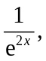 [1]
(ii) 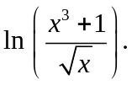 [2]

2 By drawing suitable graphs or otherwise, solve the inequality 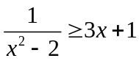. Hence solve the inequality 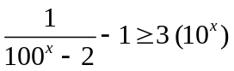. [4]

3 Find, algebraically, the set of values of p (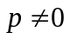) for which
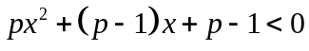
for all real values of x. [4]

4 Without using a calculator, solve the simultaneous equations
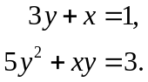 [4]

5 Find
(i) 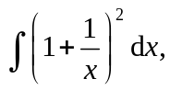 [2]
(ii) 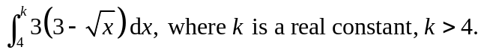 [4]

6 Sand falls from a chute at a constant rate of 15 cm³ s^{–1}, making a conical pile of semi-vertical angle 60 º. After t s, the radius of the cone is r cm and the height is h cm.
60 º
h cm
r cm
When the area of the base of the pile is 450 cm²,
(i) find the exact value of r and show that 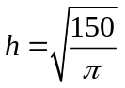, [3]
(ii) find the rate at which h is increasing. [4]
[Volume of a cone with radius r and height h is given by 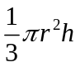]

7 (i) On a single diagram, sketch the graphs of 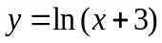 and 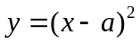, where a is a positive constant, stating clearly the coordinates of any points of intersection with the axes and the equation of any asymptote. [3]
(ii) If the graphs intersect at the y-axis, write down the exact value of a. Hence find the x-coordinate of the other point of intersection, giving your answer correct to 5 significant figures. [2]
(iii) Using the answers in part (ii), write down as an integral an expression for the area of the region bounded by and . Evaluate this integral, giving your answer correct to 2 decimal places. [2]

Section B: Statistics [60 marks]

8 A and B are two events such that 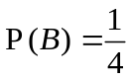, 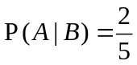 and 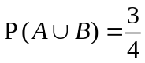.
(i) Find 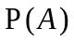. [3]
(ii) Show that A and B are not independent. [1]
9 A country club has 300 members. The executive committee wishes to know the type of activities the members preferred. Questionnaires on preferences of activities are to be given to 50 of the members.
(i) Explain how a systematic sample is used to determine the 50 members. [3]
(ii) Give an advantage of this method. [1]

10 The mean and variance of a binomial random variable X are denoted by  and 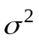 respectively. When 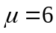 and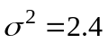, find 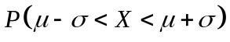, correct to 2 decimal places. [4]

11 The probability that a man will leave his office by 6 p.m. is 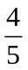 if his wife cooks dinner for him. If his wife is not cooking dinner, he will leave office after 6 p.m. with a probability of 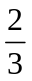. On any particular day, the probability that the man’s wife will cook dinner is 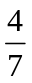.
(i) Draw a tree diagram to illustrate this situation. [2]
(ii) Find the probability that the man will leave his office after 6 p.m. [2]
(iii) Given that on a particular day, the man leaves his office by 6 p.m., find the probability that his wife cooks dinner for him on that day. [3]

12 In a certain country, 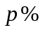 of the adults are left-handed.
Eight adults are chosen at random. The number of adults who is left-handed is denoted by the random variable, X.
State in the context of this question, an assumption needed to model X by a binomial distribution. [1]
(i) Given that 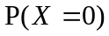= 0.272, show that the 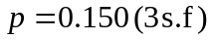 [2]
Use the value of p in part (i) for the rest of the question.
Ten such samples of eight adults are taken.
(ii) Find the probability that four of these samples each have no adult who is left-handed.
[2]
Six adults are randomly selected and asked if they are left-handed.
(iii) Find the probability that the 6th adult is the first adult who is left-handed. [2]
13 Packages of an isotonic drink are labeled as 275 grams. However, customers complained that the actual content in the package is less than 275 grams. The manager decided to take a sample of 50 packages and the content x grams of each package is measured. The results are summarized by 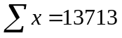, 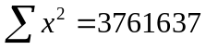 .
The population mean content of the package is denoted by grams. The null hypothesis 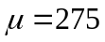 is to be tested against the alternative hypothesis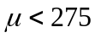. Find the p-value of the test and state the meaning of this p-value in the context of the question. [5]
State, giving a reason, whether any assumptions about the population are needed in order for the test to be valid. [1]
A second random sample of 30 packages is tested and the content y grams of each package is measured, with results summarized by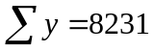, 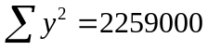.
Combining the two samples into a single sample, carry out a test, at the 10% significance level, of the same null and alternative hypotheses. [5]

14 The rate of growth, y, of a particular organism in a laboratory is believed to depend in some way on the controlled temperature;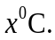The table shows the results of 7 experiments.
Experiment | 1 | 2 | 3 | 4 | 5 | 6 | 7
Temperature, | 6 | 9 | 11 | 14 | 18 | 22 | 25
Rate of growth, y | 5 | 13 | 15 | 21 | 20 | 24 | 26

(i) Give a sketch of your scatter diagram for the data, as shown on your calculator. [2]
(ii) Calculate the product moment correlation coefficient, and comment on its value in relation to your scatter diagram. [2]
- Find and , and mark the point 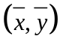 of your scatter diagram. [2]
- Calculate the equation of the regression line of y on x, and draw this line on your scatter diagram. [2]
(v) Estimate the temperature in the laboratory when the growth rate of the organism is 18.
[2]
(vi) The research assistant uses the regression line in part (iv) to predict the growth rate of the organism when the temperature in the laboratory is 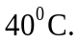Comment on the reliability of this prediction. [1]
15 The total playing time of a soccer match may be modelled using a Normal distribution with mean 93 minutes and standard deviation of 0.9 minutes.
(i) Find the probability that the total playing time of a particular soccer match is less than 92 minutes. [2]
(ii) Find the probability that the total playing time differs from the mean time by more than 2 minutes. [2]
(iii) Using a suitable approximation, find the probability, that in fifty soccer matches, there are at least fifteen in which the total playing time is less than 92 minutes. [5]
(iv) Find the probability that the total playing time of 10 soccer matches exceed 935 minutes. [3]

 End of Paper 

